**Names:** Azabe Patrick

**ID:** 22943

**Topic:** Football League Management System

**Project Documentation**

1. **Project requirements**

* **Purpose of the project**

The purpose of this web project was to create a web application that can help a football federation manage their league competition. That includes a season that is being played, teams that are playing in that season and how teams face each other on a daily basis. With the help of different web development skills and technologies this was able to be achieved.

* **Description of project requirements**

**Function requirements:** in functional requirements we explain how different forms and tables work together to achieve our goal from input of the season and activating it so that teams participating in that year can be able to register themselves on it to teams’ registration and teams’ data used to register matchday where you are able to manipulate all data meaning update and delete.

**Data management:** all data were store in postgres DBMS and retrieved from there on different pages and tabled

**Performance:** using spring boot, html, CSS and bootstrap the performance of the web application was fast and interactive.

**Security and authentication:** with the help of spring security the spring boot dependency all the security and authentication were summed up on the log in and signup to make an interactive and secure web application.

1. **Project plan**

* **Scope of the project:** the scope of this project is based around managing teams, seasons. And matchday (results and time of fixtures and their status if they are live, ended or upcoming)
* **Timeline:** It took two weeks to do this web applications sleepless nights but am happy we have this end product
* **Resources used to complete the project:** (YouTube, chatgpt, stack overflow, etc.)
* **expected outcomes:** the expected outcome is to have a working football league management and we have achieved that.

1. **Source code**

* **Configuration files required to run the application:** you need to configure application properties to map it with your database under an existing database with your credentials use to log on in your DMS

1. **Database schema**

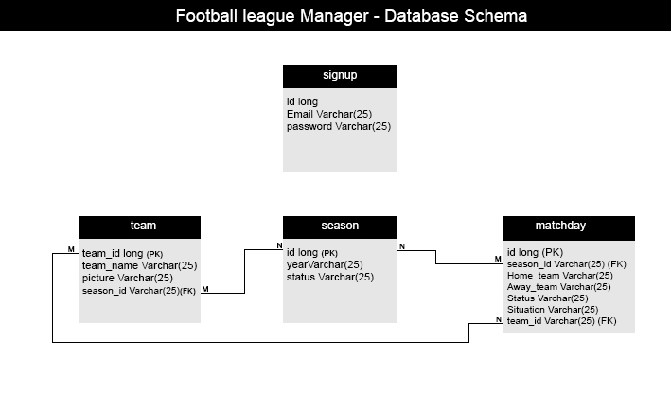

1. **User documentation**

* **Login credentials**

**(**Email: azabepatrick34@gmail.com, password: 12345**)**

* **How to navigate the applications**
* Open the link URL
* Login or create an account
* Dashboard home page with total of items saved
* Open forms or display pages
* **Features and functionality that are available**
* Matchday, team, season form
* Home page
* Matchday, team, season list

1. **Technical documentation**

* **Architecture of the system:** the system is built MVC model the model for database and tables creation, controller for managing mapping of different pages, repository, service and view for displaying and inputting data
* **How it was implemented**

I started by creating the models for them to create tables automatically in my database and then proceeded to create repository that serves as the interface between model and service. Then in service I initiate the CRUD operations and implemented them then proceeded with the view to configure actions of inputting and output on my pages and then implement login and signup

* **Libraries & frameworks used**

**Languages**

* Html
* CSS
* Bootstrap
* JavaScript

**Frameworks:**

* Spring tool suite 4
* Postgres 9.4

**Libraries:**

* Spring data-jpa
* Thymleaf
* Spring web dev tool
* Postgresql

**Screenshots:**